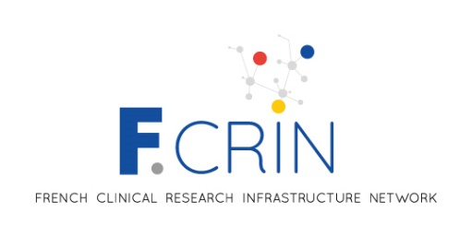
Campaign for network labellization 2025
-
Application for labellisation
Letter of Intent

Deadline to apply: 11 October 2024
Contact : us015-fcrin@inserm.fr
Network name
Coordinators (name/email)
Thematic of research

Description of the initiative (5 pages max).
(free text; english; arial 11; inter 1,15)

Please refer to the LOI guidelines and F-CRIN network specifications.

